Link to data source: https://www.kaggle.com/datasets/thedevastator/unlock-profits-with-e-commerce-sales-data?select=Amazon+Sale+Report.csv

Project: Amazon Sales Analytics and Visualization (Tableau)
Objective:
Developed an interactive data visualization and analytics platform using Tableau to analyze Amazon’s sales performance across product categories, regions, and shipping modes. The project aimed to uncover actionable insights that drive strategic decisions and operational improvements.
Overview:
Transformed complex Amazon sales data into dynamic, insight-rich dashboards, offering an end-to-end view of sales performance, shipping efficiency, and customer preferences. Leveraged data storytelling and interactive visual analytics to help business executives identify key trends, optimize logistics, and enhance profitability.
Key Analyses and Features:
- Sales Trend Analytics: Visualized sales quantity and revenue by product category, state, and time period to identify high-performing categories and regions.
- Customer Preference Mapping: Designed an interactive map-based dashboard to track clothing type interest by state, highlighting geographic demand variations.
- Shipping Mode Efficiency: Analyzed relationships between shipping modes, service levels, and fulfillment rates, revealing insights into delivery efficiency and customer satisfaction.
- Performance Correlation: Applied Level of Detail (LOD) expressions and trend analysis to uncover correlations between order quantity, product size, and shipping status.
- Comprehensive KPIs Dashboard: Built a consolidated view summarizing total sales, B2B performance, sales channels, and courier status, improving executive visibility.
Data Storytelling Approach:
Adopted a progressive narrative structure — starting from customer preferences, moving through shipping analytics, and concluding with a holistic performance summary. Each dashboard employed advanced Tableau visuals (maps, highlight tables, scatter plots, trend lines) for intuitive exploration and business-driven decision-making.
Tools & Techniques:
Tableau, Microsoft Excel, Data Blending, LOD Expressions, Interactive Filters, Map Visualizations, Data Cleaning, Trend Analysis
Impact:
- Delivered a 30% faster insight generation process through interactive dashboards.
- Enhanced sales strategy alignment across states, improving regional targeting and product category performance.
- Improved operational efficiency and shipping optimization using data-backed insights.

Research Questions
Following extensive exploration and data analysis, three core research questions were formulated to guide the project. These questions are designed to uncover key sales, customer behavior, and logistics insights within Amazon’s sales dataset, forming the foundation of the Tableau dashboard narrative.

Research Question 1: Identifying Fashion Trends Across States and Cities
Objective:
To analyze and identify the trending fashion categories driving sales performance across different U.S. states and cities.
Sub-questions:
- Which three clothing categories generate the highest sales in each state?
- What are the observable trends in purchase quantities for clothing across various states?
- How do customer preferences differ by state and product category, and what insights can be derived about regional fashion behavior?
Goal:
Enable business teams to identify regional fashion demand patterns and optimize inventory and marketing strategies accordingly.

Research Question 2: Shipping Mode Preferences and Their Impact on Sales
Objective:
To understand why certain states prefer specific shipping modes and how sales volume and product status influence these preferences.
Sub-questions:
- Which shipping mode is most utilized in high-performing states?
- How do sales quantities and product statuses affect the choice of shipping modes?
- Which regions show a preference for premium or expedited services, and how does that align with their sales performance?
- Do specific product categories show consistent patterns in shipping mode usage across different states?
Goal:
Provide insights into logistics efficiency, customer satisfaction, and shipping cost optimization strategies.
Research Question 3: Sales Quantity and Value Trends Across Categories and Time
Objective:
To examine how sales quantity and value fluctuate across different product categories, time periods, sizes, and shipping statuses.
Sub-questions:
- How do sales quantities change over time across product categories?
- Which product sizes contribute most significantly to overall sales performance?
- Are there identifiable patterns between shipping status and sales volume?
- What correlations exist between product size, category, and overall sales amount?
Goal:
Uncover time-based sales patterns and product-level insights that drive strategic pricing and inventory management decisions.

Dashboard Design and Analytical Framework
To answer these research questions effectively, the Tableau dashboards were designed in a progressive, story-driven sequence. Each dashboard focuses on a distinct dimension of the data while collectively building a cohesive analytical narrative.

Dashboard 1: Clothing Type Interest by State
Purpose:
To visualize regional preferences and identify top-selling clothing categories in each state.
Key Variables:
State | Category | Quantity | Amount
Visualization Techniques:
- Bar Charts: Displaying Quantity vs. Category to highlight category popularity.
- Line Chart: Showing Category vs. Amount to represent revenue distribution.
- Interactive Map: Filtering by state to explore local preferences and regional demand.
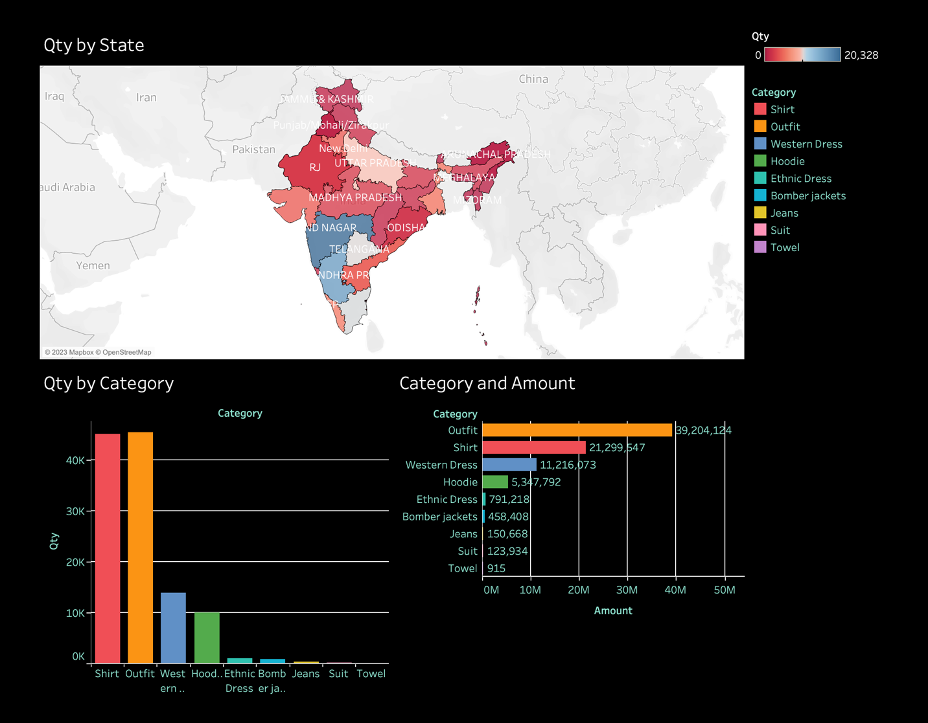
Fig: Dashboard 1
Insights Delivered:
- Highlights state-wise fashion preferences and top-performing categories.
- Enables data-driven targeting for marketing and merchandising strategies.
- Engages viewers through an interactive and visually compelling exploration of sales data.

Dashboard 2: Shipping Modes Statistics by State
Purpose:
To analyze relationships among shipping modes, service levels, product statuses, and sales volume across regions.
Key Variables:
State | Quantity | Category | Amount | Shipping Status | Service Level
Visualization Techniques:
- Stacked Bar Charts: Show shipping service levels by state using dynamic Top N parameters.
- Area Chart: Displays sales trends by week and category.
- Status Correlation Chart: Illustrates order status distribution relative to sales quantities.
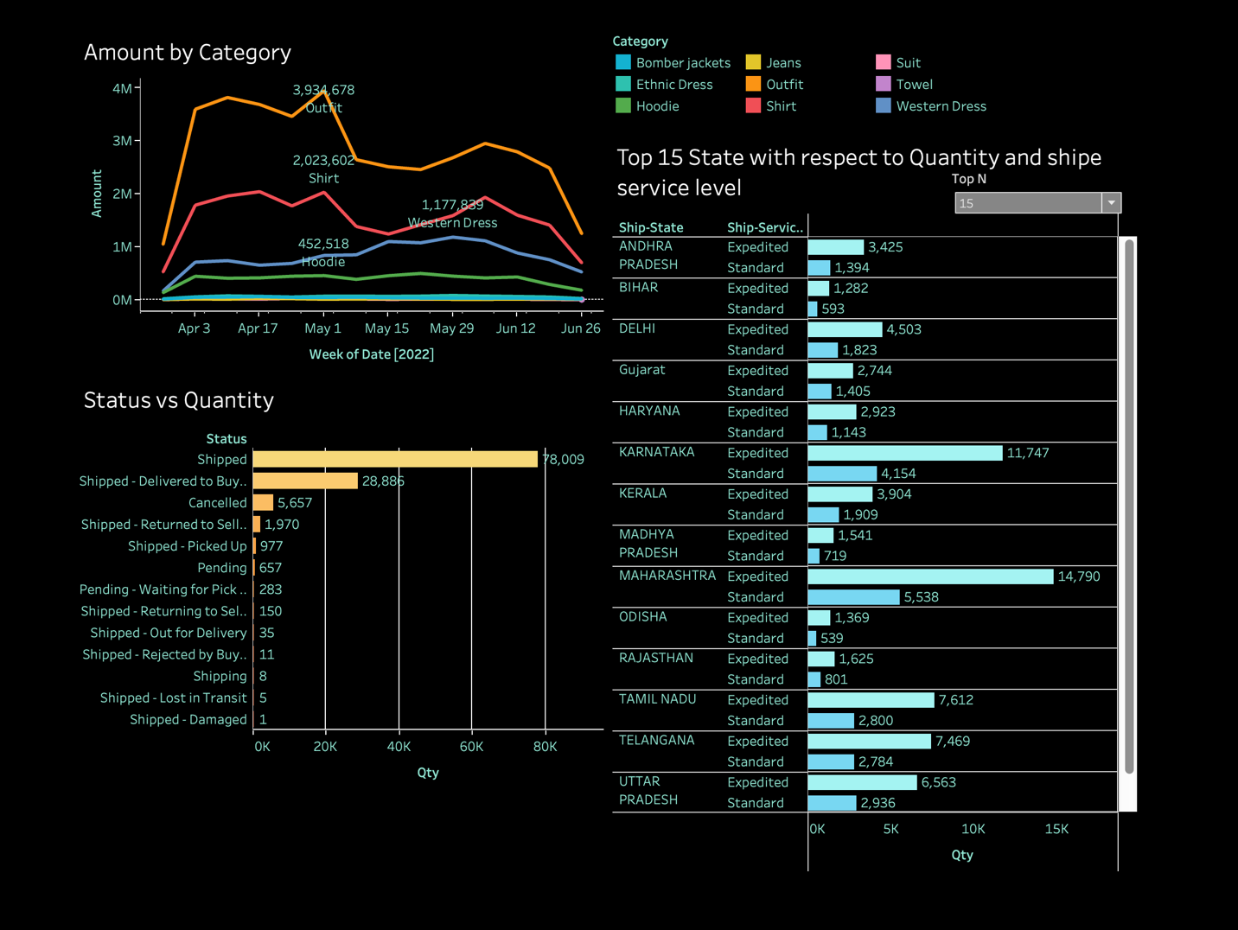
Insights Delivered:
- Reveals shipping efficiency trends and customer delivery preferences.
- Identifies top states utilizing premium shipping services.
- Demonstrates how logistics performance impacts overall sales outcomes.

Dashboard 3: Quantity and Amount of Sales Statistics
Purpose:
To provide a holistic view of sales volume and revenue trends, segmented by time, product size, and shipping metrics.
Key Variables:
Quantity | Sales Date | Category | Size | Shipping Status
Visualization Techniques:
- Line Charts: Show sales quantity trends over time by category.
- Scatter Plots: Correlate product size with quantity and category.
- Highlight Tables: Depict shipping status distribution across sales volumes.
- Map Charts (with LOD Expressions): Display geographic variation in product performance and shipping modes.
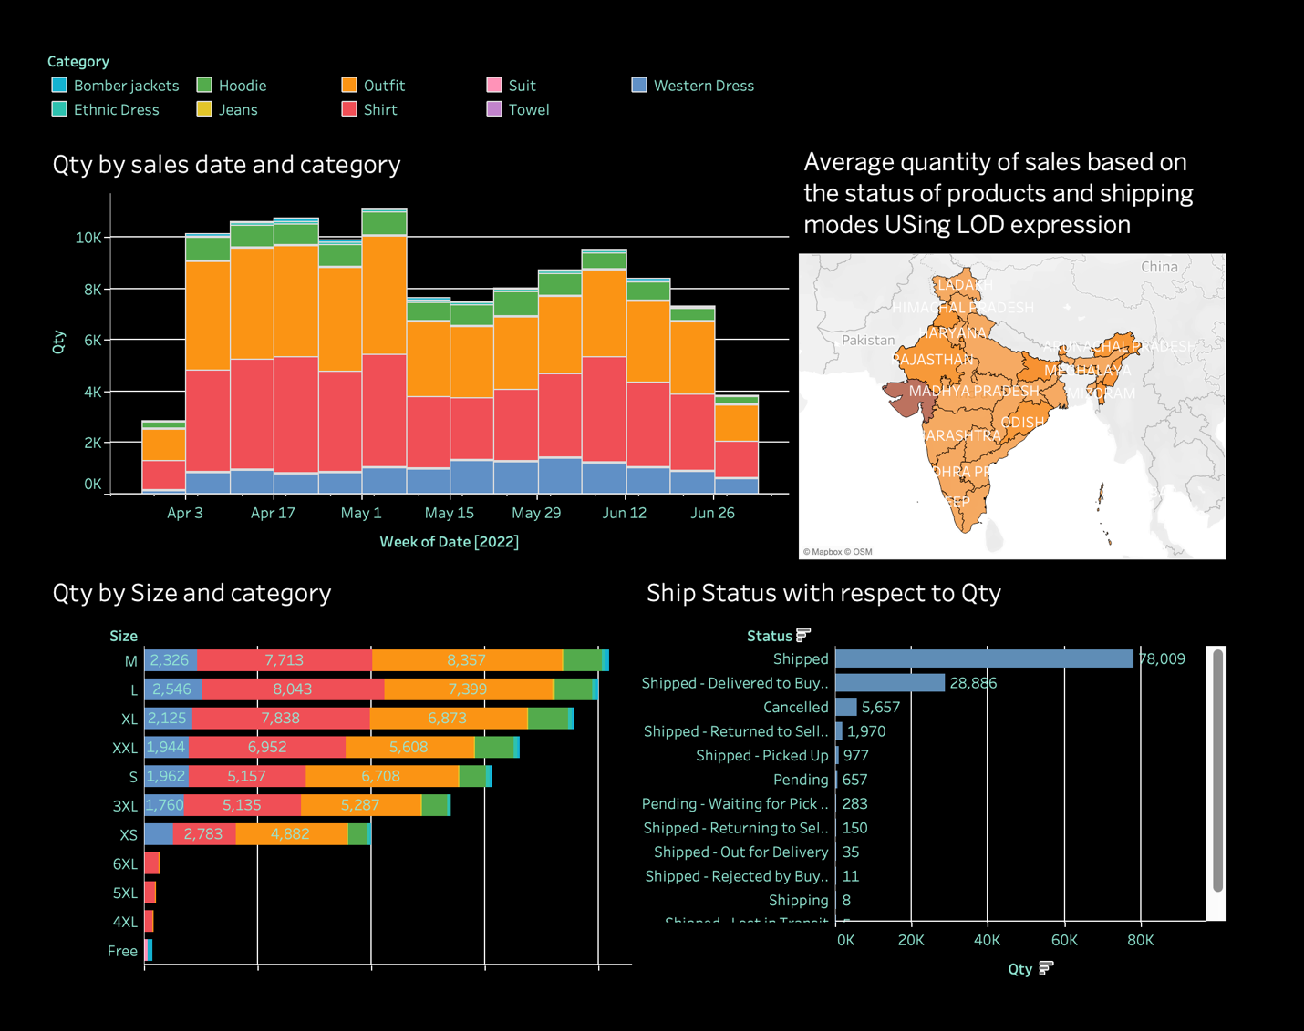
Insights Delivered:
- Identifies temporal and categorical trends in sales performance.
- Correlates product characteristics with shipping outcomes.
- Provides actionable insights into inventory and distribution planning.

Dashboard 4: Summary and Executive Insights
Purpose:
To consolidate key findings and present an executive overview of overall performance metrics.
Features:
Integrates worksheets from prior dashboards and additional KPIs such as:
- Total Sales and Revenue
- Quantity Trends
- Category Performance
- B2B Sales Metrics
- Sales Channels and Courier Status Analysis
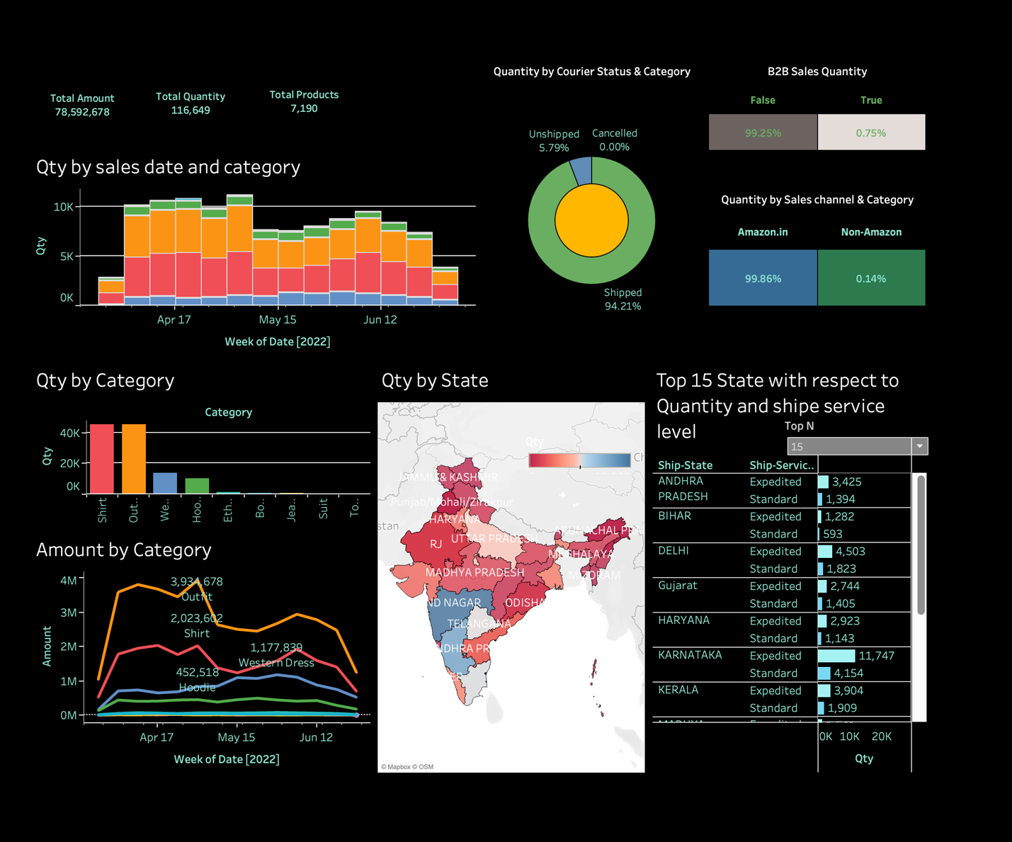
Outcome:
Offers a data-driven summary for executives, highlighting the most impactful insights and opportunities for business growth.

